2025/12/26
I worked on gpt2
Learned its architecture

Input tokens (768 dimensional values), you sum them with the position encodings (also 768 dimensional). That’s what enters the machine.
For creating the next token, you make it go through a linear normalization layer, and let the residue go through, then self attention + residue, layer normalization + residue and finally multilayer perceptron + residue.

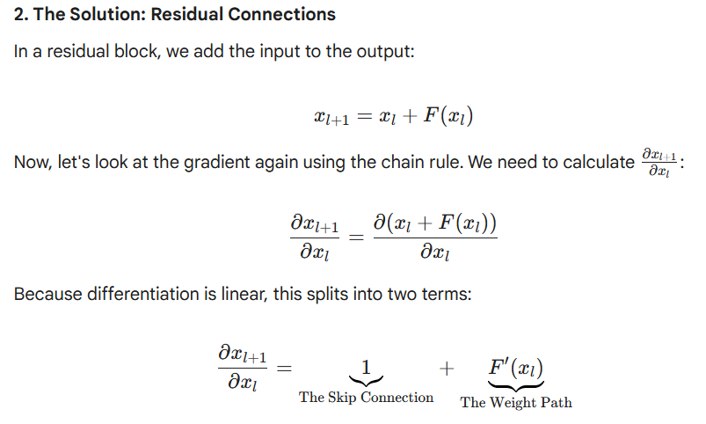
The residue prevents the vanishing derivative problem:
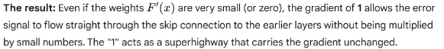
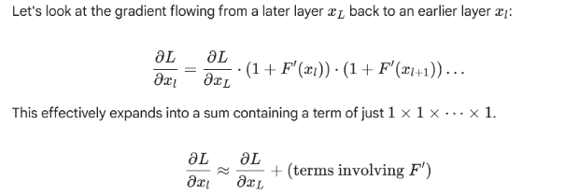
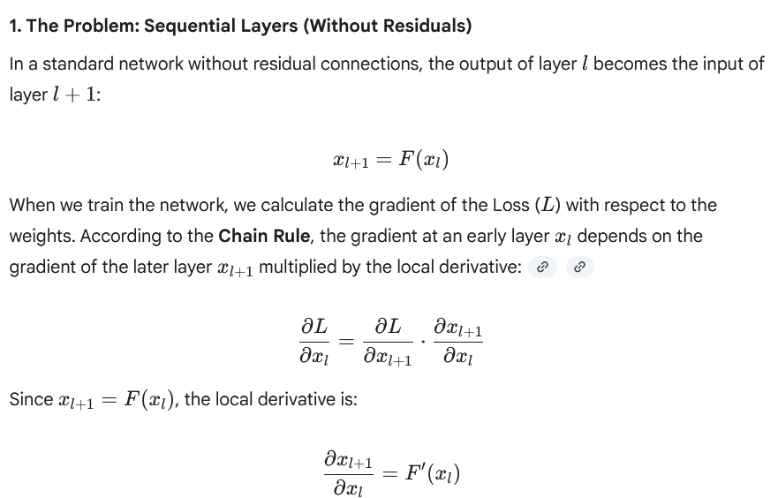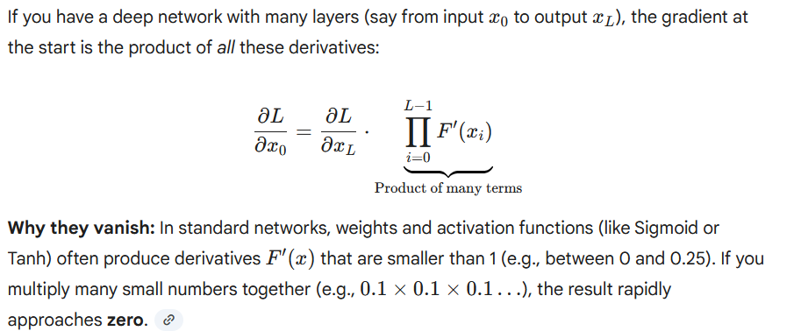

The causal self-attention is what gives the machine context of the previous tokens (I don’t really get how this works).
Once the context has been gathered, multilayer perceptron is used to make a prediction of what the next token should be. In the multilayer perceptron, for some reason I don’t understand, the size of x is multiplied by 4, then GELU activation, and then projected back to the original size. I WANT TO CHECK WHY WE DO THE X4 the MLP contains the knowledge base of the transformer. Specifically, it is all stored in its weights. We do x4 so that the matrix of weights is bigger and more data can fit.

Multilayer perceptrón (4x expansion, GELU, 0.25x projection)
Attention layer
Normalization layer
Normalization layer
I’M NOT VERY CLEAR: IS ALL THE INPUT STRING GIVEN AS AN INPUT TOKEN?
Input tokens (Each token is represented by a position in a 768 dimensional space. There are in total 65257 different tokens, 256 represent the basic 1 byte characters [extended ASCII], 1 stop string character and 50000 combinations of the basic characters [for example: “the ”, “or ” are likely tokens])
Position embedding (adds info about the position the tokens of interest occupy. Remember that the output can be at most 1000 characters long. A character at the beginning and at the end act differently)

29th December
Today I played around with https://bbycroft.net/llm
It was great to understand how a simple LLM works. I understood SelfAttention better: you have n heads. Each head looks at something different. The head size (hs), is n_embd/n_head=768/12=64 in the case of GPT2. Each head looks at 1/12th of the channels (this is not always necessary, it is also possible for each head to look at all channels, could be useful for small models/few heads. Nanogpt, for example, uses it), and performs a multiplication with the given weights for Q, K and V + bias. Each head compares the query (the representation of the current token) to the keys of previous tokens (by matrix multiplication) and outputs a number saying how similar they are. Finally, it adds all the Values weighted by how similar they are to the current token.

All this can be parallelized. Instead of calculating the Q, K and V separately, they can be all calculated at the same time in the same matrix, making the process way faster.

2nd of January
The last few days, we added a tokenizer that is able to convert plain text to gpt2 tokens, then we put it into a tensor, sent the tensor to the gpu using tokens.to(device), where device is ‘cuda’; as we wanted to do simultaneous predictions, we copied the same input string B=5 times, giving us a tensor of dimension (B, T), and finally, we did logits=model(x), giving us a tensor of shape (B, T, vocab_size) [remember, vocab_size=50257]. It contains the unnormalized probabilities that a certain token should come afterwards.
What we can do afterwards is,

We use the same weights for input token embeddings (compress 50257 to 768) as well as the output layer that goes from 768 to 50257

3rd of January recap
“Hello, I am a language model” gets converted into a list of T tokens. We turn it into a tensor, and make several copies of it, getting a (B, T) tensor: [[15496, 11, 314, 1101, 257, 3303, 2746, 290], [15496, 11, 314, 1101, 257, 3303, 2746, 290], [15496, 11, 314, 1101, 257, 3303, 2746, 290]] this is a (3, 8) sized tensor
We input this (B, T) tensor in our GPT model. The GPT model first converts using a dict each token is a key pointing towards a 768-dimensional vector [the dictionary used to do so is wte (weight token embeddings), and its dimensions are (50257, 768).
We also have wpe (weight position embedding), this gives positional info about the tokens, and it’s a (1024, 768) tensor, 1024 being the max amount of tokens that our neural network can produce as an output.
From the sum of both wte and wpe we get the input embedding, we get a (B, T, 768) tensor.
This vector will go through our 12-layer transformer. Each of the layers is made of two blocks: first, a layer norm + self attention with residual path; afterwards, another layer norm + Multi-Layer Perceptron (MLP) with GELU activation and residual path
In the first block, we make our (B, T, 768) tensor go through a normalization layer, we want the mean of each of the 768-dimensional vectors to be 0 and the standard deviation (STD) to be 1. For that we calculate the mean and STD. Afterwards, we subtract the mean and divide by the standard deviation.
[Added by GEMINI: After normalizing to mean=0 and std=1, the layer applies two learnable parameters per dimension: (scale) and (shift). This allows the model to "undo" the normalization if it decides that the raw mean/variance contained useful information.]
WHY DO WE NEED A NORM LAYER? If a = [10.0, 20.0, 30.0, 40.0, 10.0, 20.0, 30.0], and we apply softmax, we get a_sftmx= [9.35e-14, 2.06e-09, 4.54e-05, 0.9999, 9.36e-14, 2.06e-09, 4.54e-05]. As can be seen, it looks like one-hot encoding. We don’t want that. On the other hand, if we make std=1 and mean=0, a_norm= [-1.25, -0.28, 0.69, 1.66, -1.25, -0.28, 0.69], and a_norm_sftmx= [0.03, 0.07, 0.18, 0.46, 0.03, 0.07, 0.18]

Now, we make two copies of the resulting (B, T, 768), one goes to the residual pathway to the next normalization block while the other passes through our self attention layer, responsible for gathering contextual info from the previous layers, so as to better predict the next token. It works as follows: it is made of 12 different heads (n_heads=12), each is specialized to look at the previous tokens for different relevant tidbits of information. Each is made of Q_weight, K_weight and V_weight tensor (Q query, Kkey, VValue) of dimensions (768, hs) [hs=64 (head space), it isn’t random, it comes from the fact that 768/n_heads=hs]. To make everything more efficient, we bunch all the weights together, and we get one (12*64, 768*3) tensor that contain the Q_weight, K_weight and V_weights of the 12 heads (we also get 12*64*3 biases, I don’t understand if they are stored in the same tensor or a separate one).
We multiply our normalized input embedding by this weight tensor, and we get a new (B, T, 768*3) tensor. We split it in three, giving us tensors, Q_vectors, K_vectors, and V_weights, each of dimensions (B, T, n_heads, hs). Finally, we temporarily transpose T and hs, getting us the final shape (B, hs, T, n_heads)
The idea is, for each head, we take our current token’s query vector and we multiply it by the previous token’s key vectors (only previous, because we want the self-attention to be causal). As we are calculating the dot product of two vectors, for each of these combinations we get a scalar value: w_ij=q[i]·k[j]/sqrt(hs), where j<=i and hs=64. We build a matrix that stores these values, we call it attention matrix. It will be of size (B, hs, T, T), in the i-th row we will have the scalars that establish how related token i is to tokens 0, 1,..,i-1, and upto i. The upper triangle will just be set to negative (because of the causality requirement, and because we will be applying softmax in the next layer).
[Why 1/sqrt(64) in the attention matrix? Because each q[i]·k[i] dot product operation is the multiplication of two 64-dimensional vectors. These vectors are made of 64 random variables initialized with mean=0 and std=1. Each product pair still has mean=0 and std=1. However, the sum of 64, while keeping mean=0, the variance jumps to 64 (and std=sqrt(64)). To keep std=1, we multiply each product by 1/sqrt(64). Why do we want this? Because t the next layer is a softmax layer. Go back to the previous text in bold if you are confused about why softmax needs mean=0 and std=1].
Now we make each of the rows go through a softmax function and we get a softmax-ed attention matrix.
Finally, we just multiply each of the V_vectors by the related row of weights in the softmax-ed attention matrix, we get as a result a tensor of size (B, n_heads, T, hs), which we call V_output.
The softmax is very important, because all the elements in the attention matrix have been scaled using 1/sqrt(hs), so they are of the same order. As the attention is causal, the top row of the attention matrix has a single non-zero weight, while the bottom one has T non-zero weights. That means that V_output’s first column would be att[1,0]*V_vector[:,0], while V_output’s last column would have much bigger values: att[T,0]*V_vector[:,0]+ …(T-1 elements in here) +att[T,T]*V_vector[:,T]. However, after softmaxing each column, att[1,0]=1, while sum of att[T,i] for 0<=i<=T, so the values in V_output’s columns will be of similar orders.
Finally, we transpose n_heads and T to their original position:
(B, n_heads, T, hs) (B, T, n_heads, hs), and we join the last two dimensions in a single one: (B, T, n_heads, hs) (B, T, 768). [we call this process concatenation of the heads. Now we have the result of each of the heads localized in one specific region of the 768-dimensional vectors]
We make all this go through a final linear layer with weights of dimensions (768, 768) and 768 bias values. This mixes the info of the heads, delocalizing it across the whole 768 indices in ways that will be useful for later processing. We call the final tensor attention_output tensor, it’s of dimension (B, T, 768)
Last step of the self attention block is adding attention_output to input_embedding through the previously mentioned residual paths. This will be useful during the training’s backpropagation stage, preventing the vanishing gradient issue.
[The residue path prevents the vanishing derivative problem:
]
Now, it’s time for the MLP (multi-layer perceptron), this takes care of processing the knowledge gathered in the self-attention layer. I’ll be quicker for this. It also has a residue path, but the mlp itself is made of an input linear layer, that expands x4 the 768 dimensional vectors, a GELU activation function, and a compression layer. GELU is basically a derivable RELU, and the x4 is useful because this allows for more weights and that means more stored knowledge.

